CSA1411-COMPILER DESIGN

LAB EXPERIMENTS

NAME:- R KALAI AMUDHAN

REG NO:- 192511292

EXPERIMENT – 8:
AIM:-
- Write a C program to find FOLLOW( ) - predictive parser for the given grammar
S → AaAb / BbBa
A → ∈
B → ∈

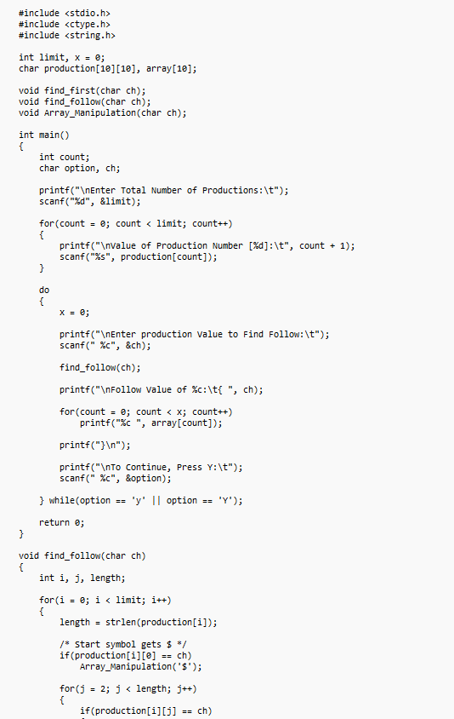
CODE:-
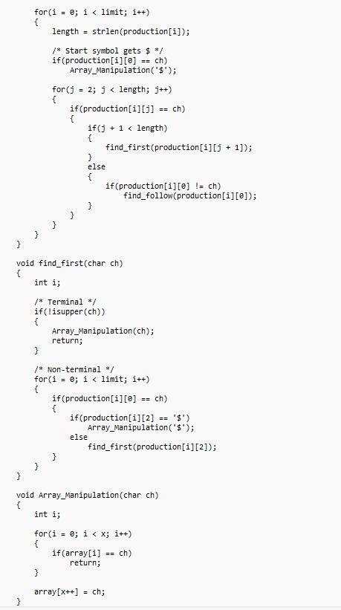

OUTPUT:-
